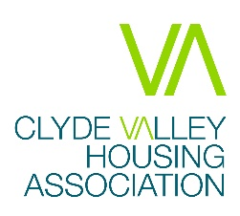

Alterations and Improvements Procedure and Form
According to the Housing (Scotland) Act 2001, any tenant who wishes to make an alteration or improvement to their property must first gain the permission of their Housing Association. Permission must be given where this is reasonable.
The Act also states that compensation should be paid at the end of a tenancy for improvements made. This information sheet will outline the process which must be followed in order for the Association to give permission for alterations and improvements and enable compensation to be paid.
Process
- Applications must be made in writing using the provided form. This can be emailed, posted, or handed into the office. Works must not begin until permission has been given.
- We may request further information from you to help us make a decision if this is required. A pre-inspection may be required for some works and will be carried out by a Technical Inspector.
- We will respond either with permission to carry out the works, or a refusal letter explaining why this is not possible. This will be received within 28 days of receiving your request, as per the Housing (Scotland) Act 2001. Failure to provide a response will be deemed that permission has been granted.
- Some works will require safety certificates to be provided, or a post inspection. You will be alerted when permission is given if this is required for your alteration or improvement.
Additional Requirements
Depending on the type of work you are wishing to carry out, you may need planning permission or consent from your council. You would need to supply this consent when you send an application to us. We cannot consider the application before the local authority’s consent is granted. You would be responsible for applying for the consent and paying any related fees.
If the post-inspection finds that the work carried out doesn’t meet the suitable standards outlined in the letter of permission, the tenant will either need to carry out the required work to bring it up to standard or put the property back to its original condition.
Some work, particularly involving electricity and gas, will require you to meet our safety standards. This means you would need to use qualified tradespeople and provide us with safety certificates upon completion of the work. For gas, you must use a Gas Safe qualified tradesperson, and for electrics you must use an NIC electrician.
Ongoing maintenance of the alteration or improvement is the responsibility of the tenant.
Appeals
We would provide the reason for the refusal of an alteration in writing.
If you are not happy with a decision to refuse an alteration or improvement, you can go through our Complaints Handling Procedure. If you are still not happy, you have the right to challenge the decision at the Sheriff Court.
If an alteration is refused, you will be advised of your right to appeal in your rejection letter.
Reimbursement
In order to get reimbursement when the tenancy ends, the tenant will need to have applied for permission in line with this policy. We will not consider backdated applications for permission where the work has already been completed.
The tenant will also need to provide receipts for the work carried out. You can claim for the cost of materials and appliances, and for the labour carried out (but not their own labour).
Full information on reimbursement can be found in our Alterations and Improvements Policy.

Alterations that are not permitted
- Any structural alterations to dwelling or relocation of internal partitions
- Any non-structural alterations to partition walls, doorways, or archways
- Laminate or wooden flooring in flats which are not ground floor
- Removal of level access or wet-floor shower rooms for bath
- Relocation of radiators or installation of fireplaces / gas fires etc.
- Ceiling fans
- Any alterations to loft spaces
- ‘Velux’ windows
- Solar panels
- Satellite dish or flag poles were attached to building or fencing
- Patio doors
- Conservatories
- Decking
- Garages or carports
- Removal of grassed areas or garden ground to lay stones, unless part of agreed measure to remedy problematic land drainage
- Wood burning stoves

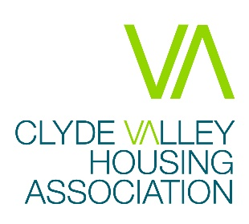

ALTERATIONS / IMPROVEMENTS FORM

1. Name

2. Address

3. Phone number

4. E-mail address

5. Description of proposed alteration / improvement

6. Location of alteration

Note – you should include a simple sketch or location plan if appropriate (for example if you want to put up a shed, lay a path or erect a fence, etc.)

7. Contractor details

Note – any work to be carried out must be done by a competent contractor or someone with the necessary skills and who complies with health and safety requirements.

8. Other permissions, etc.

Note – for certain types of work you may require planning permission or building warrants, and you should seek advice from your local authority before submitting your application.

9. Signature and date

I confirm that I have read and understand the supporting notes on alterations and improvements.

Signed Date

10. Submitting your application

Once you have completed your application, you should send it to us via email at cvha@cvha.org.uk. If you require to send by post, send to:

Housing Maintenance Manager
Clyde Valley Housing Association
50 Scott Street
Motherwell
ML1 1PN

Please remember to include your sketch or location plan (if applicable), and any relevant council permissions.

If you wish to discuss your application, you can phone the Housing Maintenance team on 01698 268855 during office hours or e-mail cvha@cvha.org.uk.

Please note that you should not commence any work until you have received written confirmation that permission has been granted.

