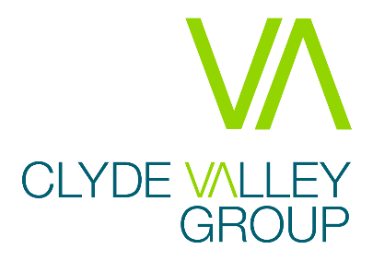

Clyde Valley Group are excited to be recruiting for an IT Assistant to join our highly dedicated team operating within our Business Improvement and Corporate Services department and help us meet the needs of our growing and successful business.
As we embark upon our new Corporate Plan for 2020-25, we are keenly aware of the challenges and opportunities we face as we continue to operate in a fast-changing sector, job market and workplace. This is a unique opportunity to deliver forward-looking, innovative and service delivery plans that provide a comprehensive response to our changing environment.
The IT Assistant must have experience of providing frontline IT support involving Office 365, Windows 10, Active Directory, networks, desktops, laptops and thin clients. An ability to work under strict deadlines and good IT fault diagnosis and rectification are also vital for this role.
In return, Clyde Valley Group offer a great remuneration and benefits package, including generous holidays and flexible working arrangements, an on-site gym and training and development.
In order to apply please visit our website for more information

Guaranteed Interview:
As a Disability Confident Employer, we’ll interview all disabled candidates who meet the minimum essential requirements for the post. If you tell us that you’re disabled, we’ll ensure that we make reasonable adjustments during each stage of the recruitment and selection process and if you join us, to where and how you work.

