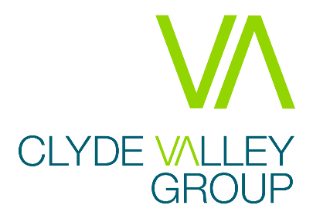

Clyde Valley Group are excited to be recruiting 2 posts of Digital and Smart think Officer & Analyst to join our highly dedicated team operating within our Business Improvement and Corporate Services Team and help us meet the needs of our growing and successful business.

- Digital and Smart Think Officer £33,642-£36,941
- Digital and Smart Think Analyst £33,642-£36,941

As we embark upon our new Corporate Plan for 2020-25, we are keenly aware of the challenges and opportunities we face as we continue to operate in a fast-changing sector, job market and workplace. This is a unique opportunity to deliver forward-looking, innovative and service delivery plans that provide a comprehensive response to our changing environment.
The Digital and Smart Think Officer must have significant experience in delivering change projects, process improvement and utilising technology to improve service delivery. The Digital and Smart Think Analyst must have significant experience in Relational Database Management systems, specifically Microsoft SQL Server Database administration and a knowledge of SQL Server Reporting services and SQL Server Report Builder. Both roles will support Clyde Valley Group to deliver against its commitments within our Corporate strategies, including our Customer Experience and Digital and Smart Think strategy.
In return, Clyde Valley Group offer a great remuneration and benefits package, including generous holidays and flexible working arrangements, an on-site gym and training and development.
Clyde Valley Housing Association is a Registered Social Landlord, owning and managing more than 4200 homes for social rent with a pipeline programme to build over 600 more. Our thriving wholly owned subsidiary Clyde Valley Property Services provides factoring services to more than 3000 owners. CVPS is also building for mid-market rent and sale as well as operating and growing a private lettings business. People see us as a trusted and influential local and regional landlord and service provider, employer and business partner working across Lanarkshire and East Dunbartonshire.
In order to apply please visit our website for more information and then send us:
- A comprehensive up-to-date CV which shows your full career history;
- A supporting statement explaining why you are interested in this role and how you match the person specification placing focus upon the essential and desirable criteria and how your previous experience matches this;
- Details of two referees (referees will only be contacted with your permission at offer stage) and current remuneration;
- The declaration form – but completion of the equalities section is not mandatory, this is requested for monitoring purposes in line with Clyde Valley Group’s commitment to equality and diversity
Please note that applications can only be considered if all the documentation is complete.
Please send your application by email to recruitment@cvha.org.uk

Closing Date for Applications: Tuesday 19th October 2021, 9am

If you wish any more information regarding Clyde Valley Group, you can visit the website at www.cvha.co.uk.
Guaranteed Interview:
As a Disability Confident Employer, we’ll interview all disabled candidates who meet the minimum essential requirements for the post. If you tell us that you’re disabled, we’ll ensure that we make reasonable adjustments during each stage of the recruitment and selection process and if you join us, to where and how you work.

